SEMESTER TWO
Papers written by Australian Maths Software

YEAR 11

MATHEMATICS METHODS
Units 1 & 2
2016
REVISION 3
Section Two
(Calculator–assumed)

Name: _________________________________

Teacher: ________________________________

TIME ALLOWED FOR THIS SECTION

Reading time before commencing work: 10 minutes
Working time for section: 100 minutes
MATERIAL REQUIRED / RECOMMENDED FOR THIS SECTION

To be provided by the candidate
Standard items: pens, pencils, pencil sharpener, highlighter, eraser, ruler.

Special items: drawing instruments, templates, notes on up to two unfolded sheets of A4 paper, and up to three calculators approved for use in examinations.

IMPORTANT NOTE TO CANDIDATES
No other items may be taken into the examination room. It is your responsibility to ensure that you do not have any unauthorised notes or other items of a non–personal nature in the examination room. If you have any unauthorised material with you, hand it to the supervisor before reading any further.

To be provided by the supervisor
Question/answer booklet for Section Two.
Formula sheet retained from Section One.
Structure of this examination

 | Number of questions available | Number of questions to be answered | Working time (minutes) | Marks available | Percentage of exam
Section One  Calculator—free | 6 | 6 | 50 | 52 | 35
Section Two  Calculator—assumed | 9 | 9 | 100 | 98 | 65
Total marks |  |  |  | 150

Instructions to candidates

1. The rules for the conduct of this examination are detailed in the Information Handbook. Sitting this examination implies that you agree to abide by these rules.

2. Write your answer in the Question/Answer booklet.

3. You must be careful to confine your responses to the specific questions asked and to
follow any instructions that are specific to a particular question.

4. Spare pages are provided at the end of this booklet. If you need to use them, indicate in the original answer space where the answer is continued i.e. give the page number.

5. Show all your working clearly. Your working should be in sufficient detail to allow your answers to be checked readily and for marks to be awarded for reasoning. Incorrect answers given without supporting reasoning cannot be allocated any marks. For any question or part question worth more than two marks, valid working or justification is required to receive full marks. If you repeat an answer to any question, ensure that you cancel the answer you do not wish to have marked.

6. It is recommended that you do not use pencil, except in diagrams.

7. The Formula Sheet is not to be handed in with your Question/Answer booklet.

Section Two: Calculator–assumed 98 marks

This section has nine (9) questions. Attempt all questions.
Working time: 100 minutes

Question 7 (10 marks)

Ben earns $35 000 per annum in 2016 with an increase of 5% each year to allow for inflation.

(a) Estimate Ben’s wage in 2017 and 2018. (2)

(b) State and describe the type of sequence Ben’s wage forms over the three years. (2)

(c) How much will Ben have earned over the next ten years if he stayed at the same job?
(3)

(d) Had Ben received $401 235.78 over the ten years, what rate of inflation had been used to
increase his salary? (3)

Question 8 (13 marks)

(a) Bob’s grandfather was a bit of a Maths Whiz. He told Bob he would give him $10 this
week, $10,50 the next week, $11 the following week and so on. He also said that by the
time he was 17, if he saved up that year’s pocket money, he would have probably be able
to buy a car.
Bob had just turned ten years old and was fascinated about being able to have a car at the end of the year he turned 17.

(i) How much pocket money did Bob receive as pocket money from his grandfather the
year he was ten? (3)

(ii) How much pocket money did Bob receive as pocket money from his grandfather as
first payment the year he turned 17? (3)

(iii) How much was Bob able to save the year he turned 17? (3)

(b) Evaluate 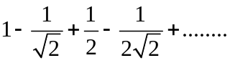
Leave your answer as a simplified surd. (4)
Question 9 (7 marks)
Consider the points A(-3,1), B(0, 4), C(4, 1) and D(0,-2) in the diagram below.
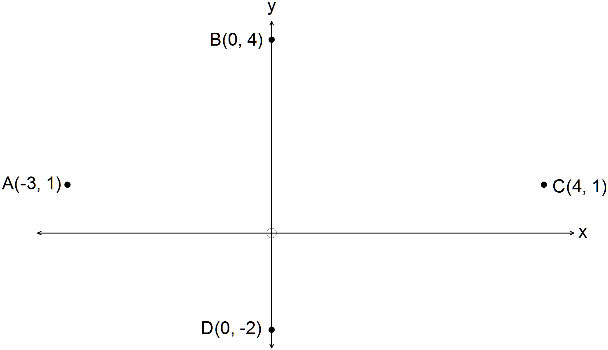

Investigate whether ABCD is a square, a parallelogram, a rhombus, a kite of a quadrilateral with no special properties. (6)

Question 10 (8 marks)
Consider the function 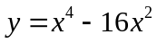.
(a) Determine the points that belong to the function where the tangent to the curve has a
slope of 0. (3)

(b) Find the equation of the tangent at 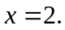 (2)

(c) Find the other points where the tangent cuts the curve again. (2)

Question 11 (14 marks)
(a) A particle is moving according to the law 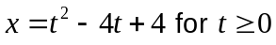 whereis measured in
seconds and is measured in metres.
(i) Find the position of the particle at 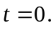 (1)

(ii) Find the expression for the velocity of the particle. (1)

(iii) Find the velocity when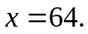 (3)

(iv) Find the position of the particle when the velocity is 2 m/s. (2)

(b) (i) Given the graph of the function 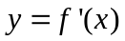, sketch the function 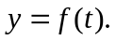 (4)

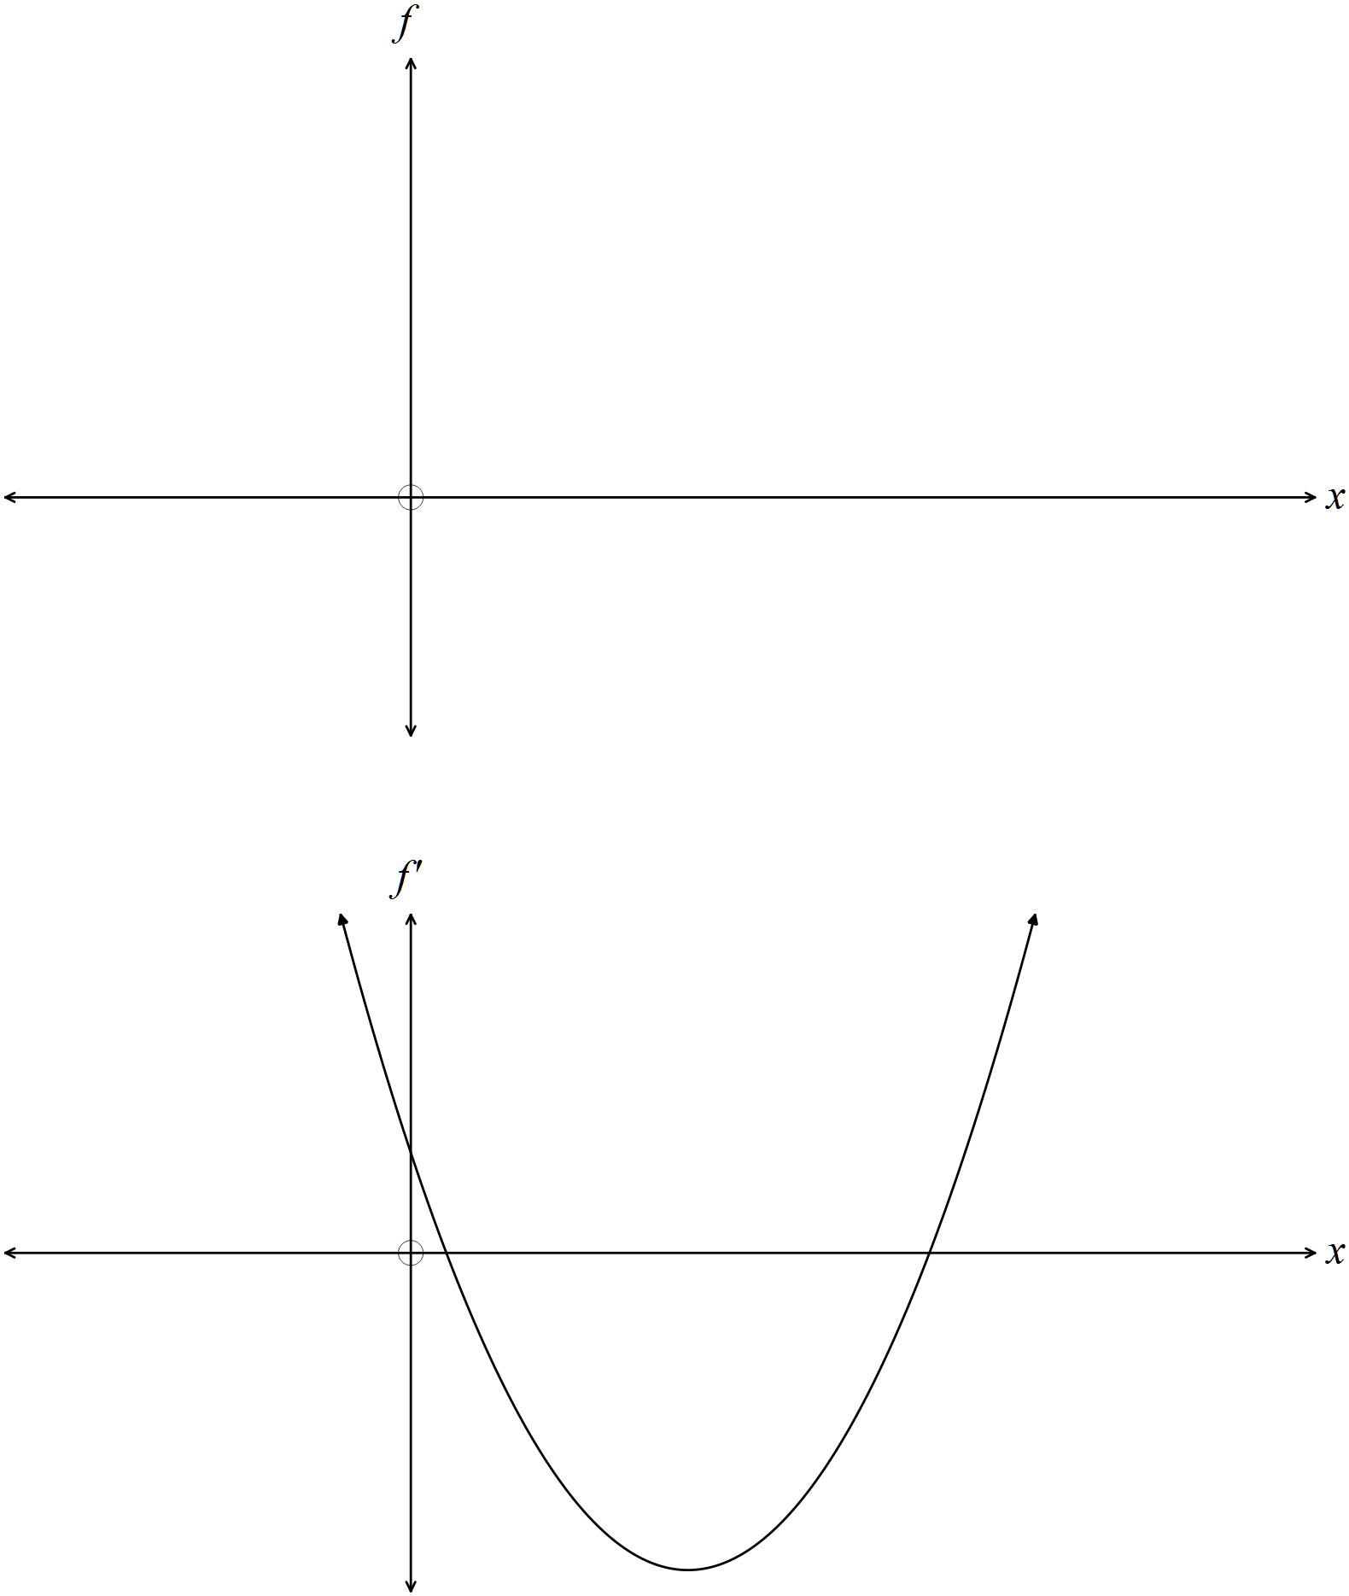

(ii) Comment on the relationship between the two functions as shown on the graphs.
(3)

Question 12 (13 marks)

(a) A circle has a diameter of 20 cm.
Which area is the bigger, the smaller segment or the smaller sector? (4)

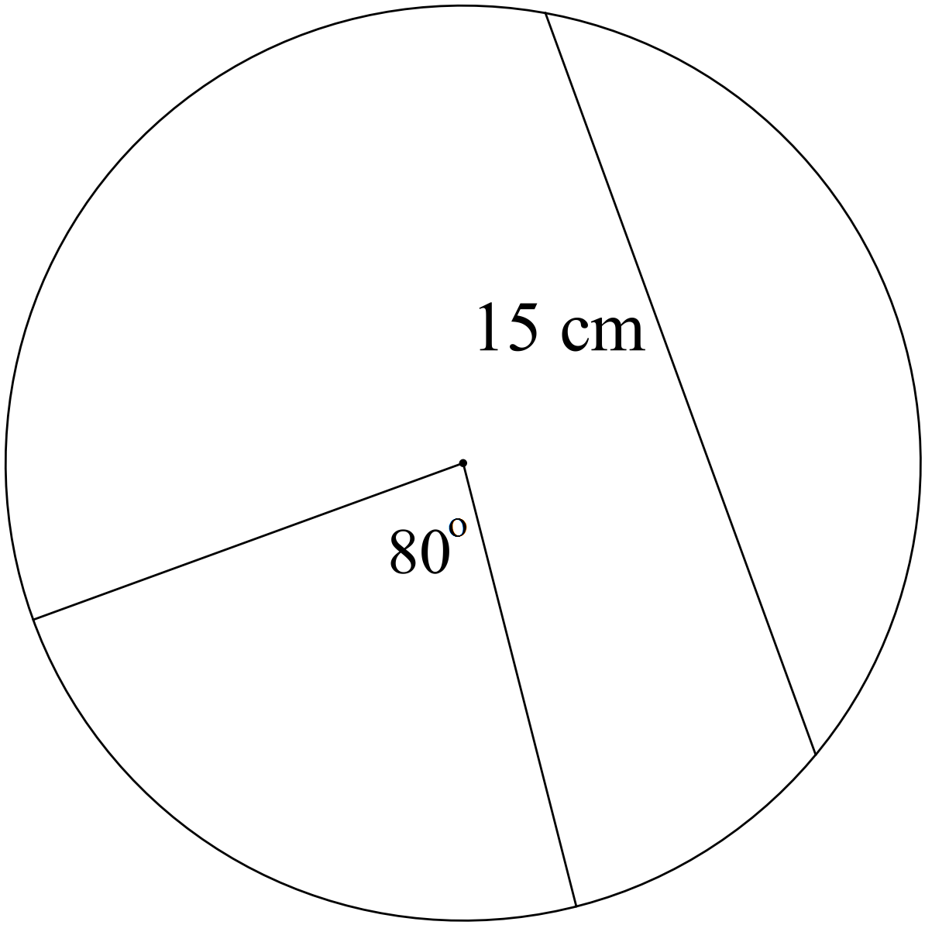

(b) Determine the equation for the trigonometric graph below. (2)

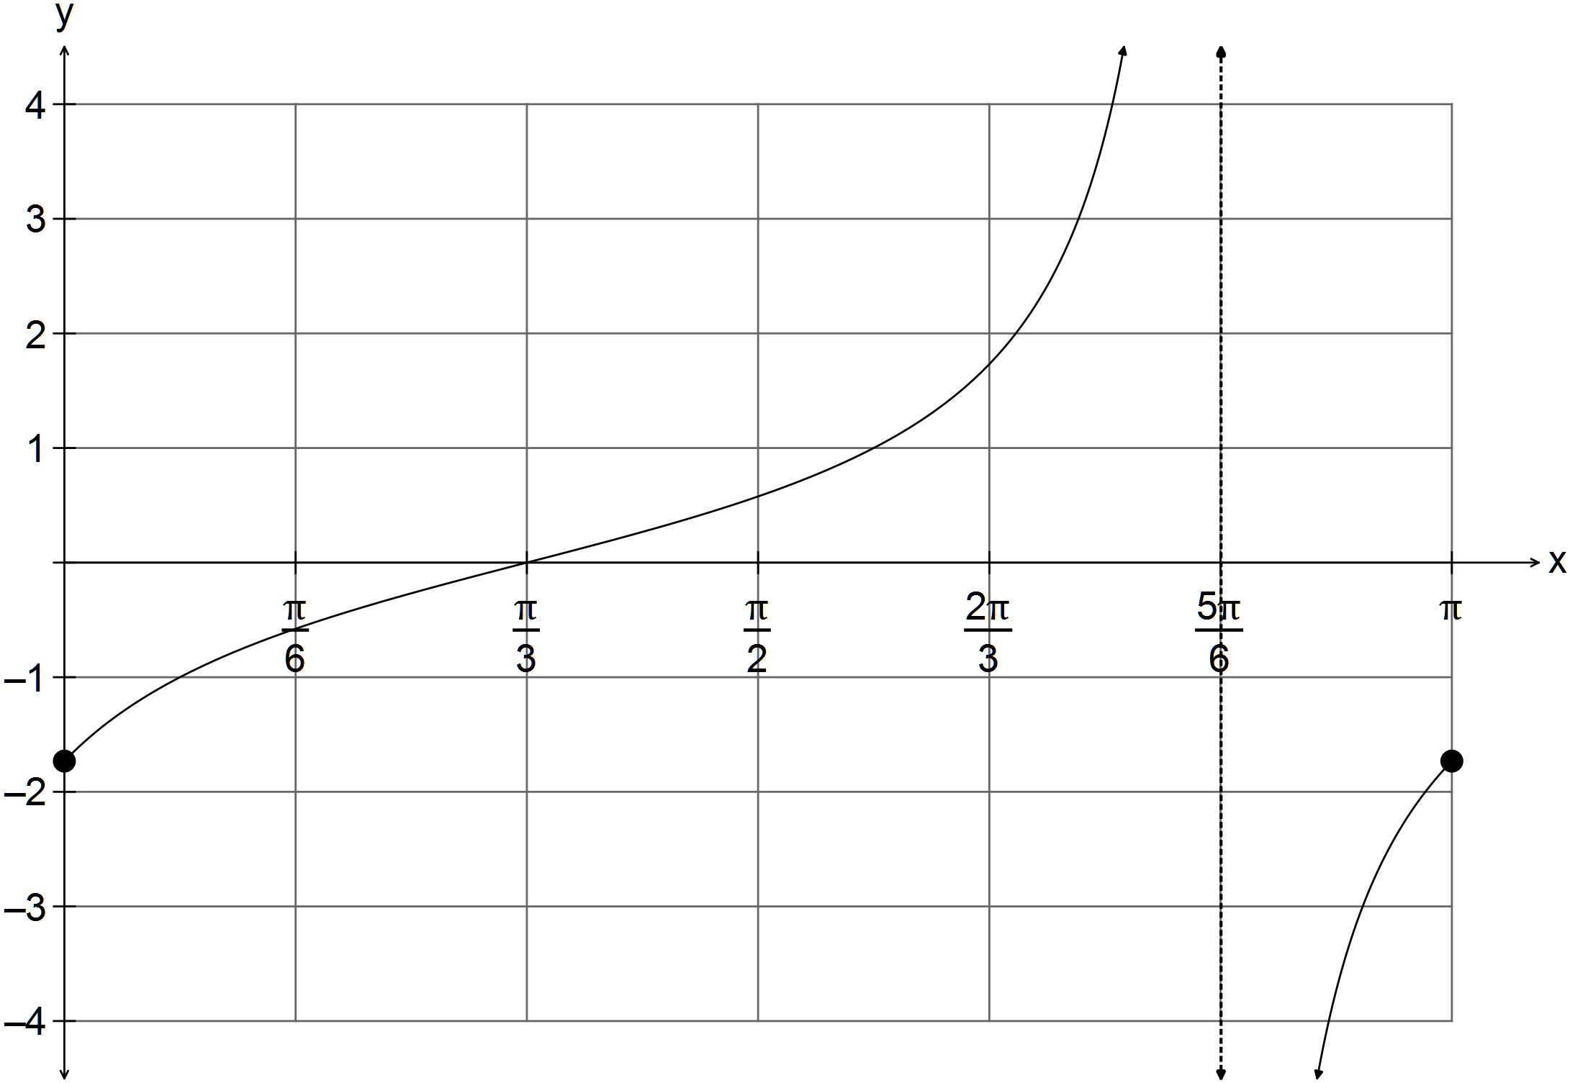
(c) Find the length of AC in the triangle below. (2)

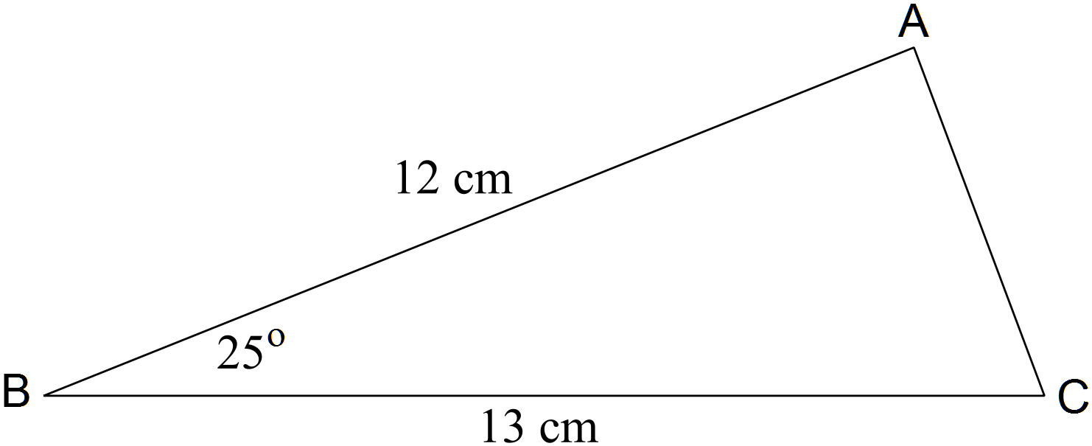

(d) Solve for given 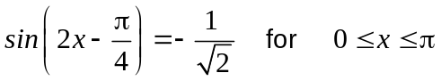 (3)

(e) Given show how to develop the formula
for 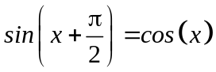. (2)

Question 13 (12 marks)

(a) Consider the function 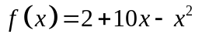 shown in the diagram below.
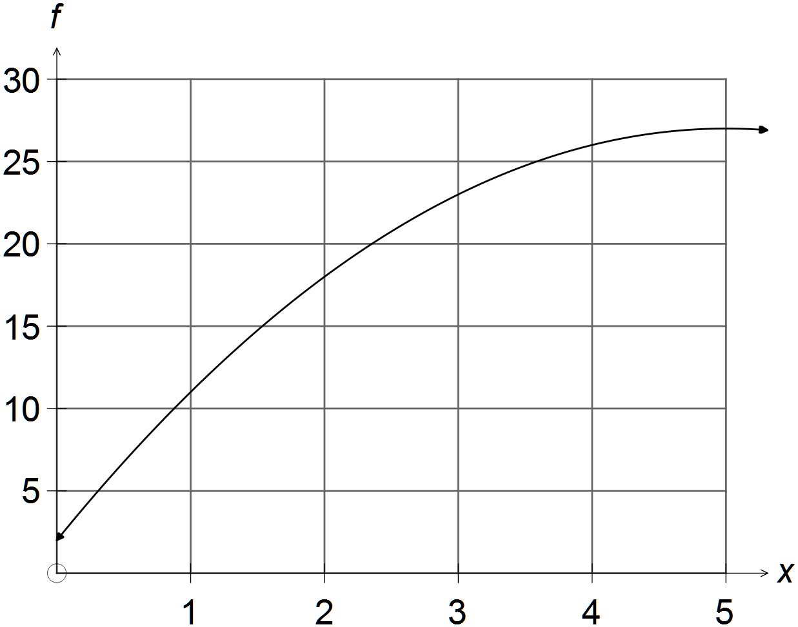

(i) Find the instantaneous rate of change at (2)

(ii) Evaluate 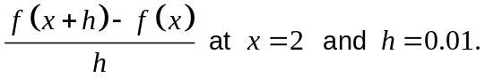 (3)

(iii) Explain exactly why your answers to (i) and (ii) are similar. (2)

(iv) Prove that the instantaneous rate of change is equal to 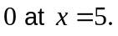. (2)

(b) Differentiate

(i) 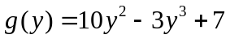 (1)

(ii) 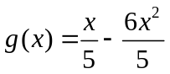 (2)

Question 14 (17 marks)
(a) Expand 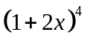 and hence determine the coefficient of 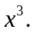 (2)

(b) Consider the chart below.

 | P | Q | R
A | 0.1 | 0.1 | 0.3 | 0.5
B | 0.4 | 0.1 | 0 | 0.5
 | 0.5 | 0.2 | 0.3 | 1

(i) Determine two events that are independent. Explain why. (3)

(ii) Determine two events that are mutually exclusive. Explain why. (1)

(iii) Find 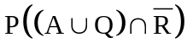. (2)

(c) Shade the region defined by 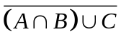 on the diagram below. (3)
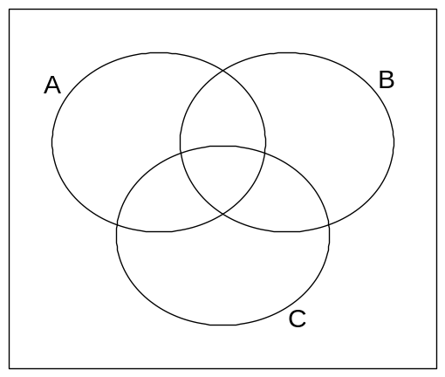

(d) Given two events M and N, it is known that
(i) Find 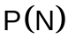. (3)

(ii) Find 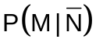. (3)

Question 15 (6 marks)

A rectangle can be formed by the x axis, x = 4 and the other two sides are lines drawn to the x axes and the line x = 4, from the point P(x, y).
The point P(x, y) is on the function  as show in the diagram below.

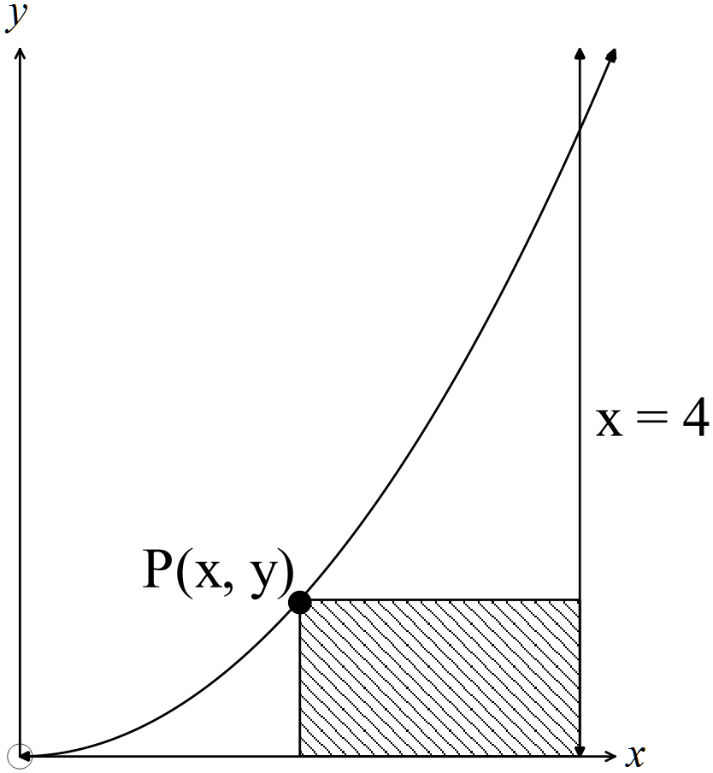

Find the point (x, y) that maximises the area of the rectangle. (6)

END OF SECTION TWO

